Dwaine Brannon

Stan Wars the Game

Welcome, stan. In this game, you will take the role of a stan twitter user to cancel your fav’s arch nemesis using items you find throughout the various rooms in their hollywood mansion; but which room are THEY in? They, aka Miss Gurl, have been subtweeting your fav all day long. You’ve replied to their tweets with things like “wow you really thought you ate, huh” “My fav ended you” and “nobody moved '', but none of the usual tactics seem to be working! So you must defeat the evil at its source, so Miss Gurl can’t drag your fav anymore. Purr! There are items hidden throughout their mansion that would lead to them getting cancelled. You will need to find: ‘Homophobic Tweets’ that they tweeted 7 years ago; Their Tax returns showing that they have only paid $90 in taxes since 2008; a ‘Yourfaveisproblematic’ Tumblr post which shows all of the problematic things that tumblr has accused them of over the years; a Mesh Mask that they used during the height of the Covid-19 Pandemic, which offered no protection against the virus; Their Cousin’s Enlarged Balls that Miss Gurl claimed were due to the Covid Vaccine, but they were really from Chlamydia; and finally; False rumors about them that you could use to get them cancelled! But be careful, because if you don’t collect all of the items before facing off against Miss Gurl, the victim will turn out to be you! You’ll be attacked by all of THEIR stans, and the game will be over. You’ll be cancelled, your twitter account will be suspended and you’ll have to find all your moots again...the horror!

Attached is a map to help you navigate your way through Miss Gurl’s Mansion

N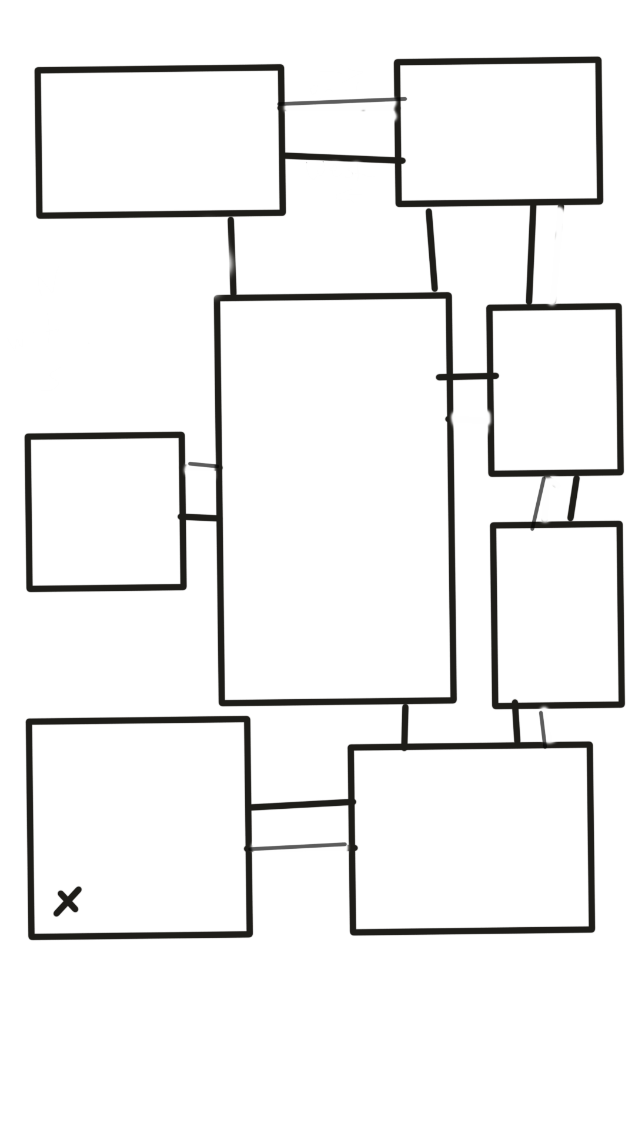

W + E

S

**Foyer Bathroom**

START Item: Vaxxine Balls

**Kitchen: Dining Room**

Item: Mesh Mask Item: Homophobic Tweets

**Awards Room**

Item: Tax Returns

**TV Room**

Item: Rumors

**Luxury Bedroom Great Hall**

**MISS GURL IS HERE** Item: ‘Yourfaveisproblematic’

Print output giving the Introduction text from above.

Define the room variables and the room items based on the map.

Ex. While Current_room = x:

room_item = y

Start: While the player’s current_room is the Foyer, from there, they can navigate east to the bathroom or south to the kitchen.

If the player inputs “east”:

The current_room for the player will be Bathroom

While current_room is Bathroom:

Print output to prompt the player to collect the room_item

If the player inputs “south”:

Current_room becomes Kitchen

While current_room is Kitchen:

Print output to prompt the player to collect the room_item

While the player input does not equal the current room_item,

Print “we ain’t got that here…choose the correct item”

While the player input is equal to the current room_item:

Print: “yas bestie!! Here’s your room_item”

If the player inputs “north” or “west”:

Print a statement saying “There ain’t no door there, dummy”

Print a statement logging which room and item the user went to, and repeat the process again with the other rooms.

When a player collects an item from a room, make a variable called collected_items and add 1 to it every time an item is collected.

If the player reaches Luxury_room before collected_items = 6:

Print: Naur Bestie...you’re cancelled. Try again?

if the user selects yes:

Run the program again

Else:

Print “not you quitting…”